Signals Systems and Transforms

Professor R Cliver

August 30, 2021

Lab 1

Yin Hinton



Section 1

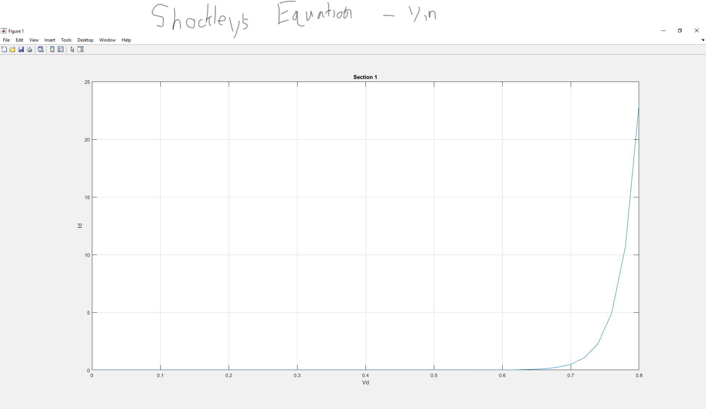

Section 2

